PRESS RELEASE

Bulgaria – Turkey IPA CROSS-BORDER PROGRAMME

(CCI Number: 2007CB16IPO008)
More than 9 million euro awarded to joint Bulgarian-Turkish development projects in the Official Ceremony held in Haskovo.

(05 July 2011)
The projects within the Bulgaria-Turkey IPA Cross-border Programme were awarded of subsidy contracts at the Official Ceremony held on 4th July 2011 in Haskovo, Bulgaria. These projects funded under the 1st Call for proposals will be in execution by July 2011. Totally 45 projects under the programme are awarded EU funding of a nearly € 9 million.

The Joint Monitoring Committee (JMC) of Bulgaria-Turkey IPA Cross-border Programme had approved under condition the projects to be financed within the 1st Call in the meeting held on 23 March 2011. Within the three-month negotiation period 45 projects fulfilled the contracting conditions set for them and were contracted with the total amount of EU subsidy reaching more than € 9 million.

Eventually, the contracts were awarded to the legal representatives of the projects at the Official Ceremony by Mr. Kiril Geratliev, General Director DG “TCM”, Ministry of Regional Development and Public Works of Republic of Bulgaria together with Mr. Bulent Cengiz, Prime Ministry Secreteriat General for EU Affairs of Republic of Turkey and Mrs. Irena Uzunova, District Governor of Haskovo.

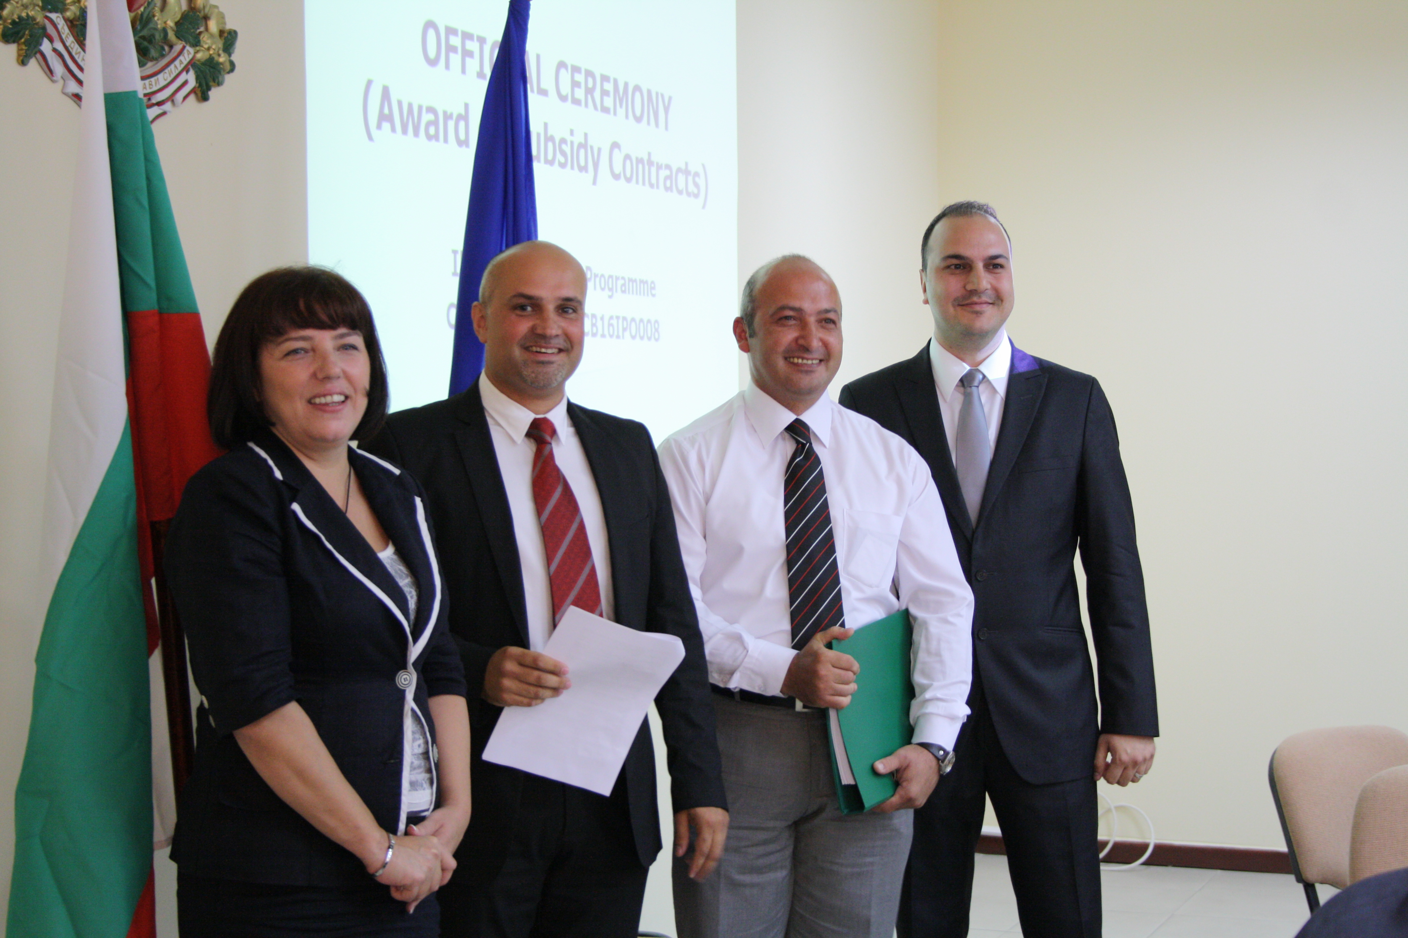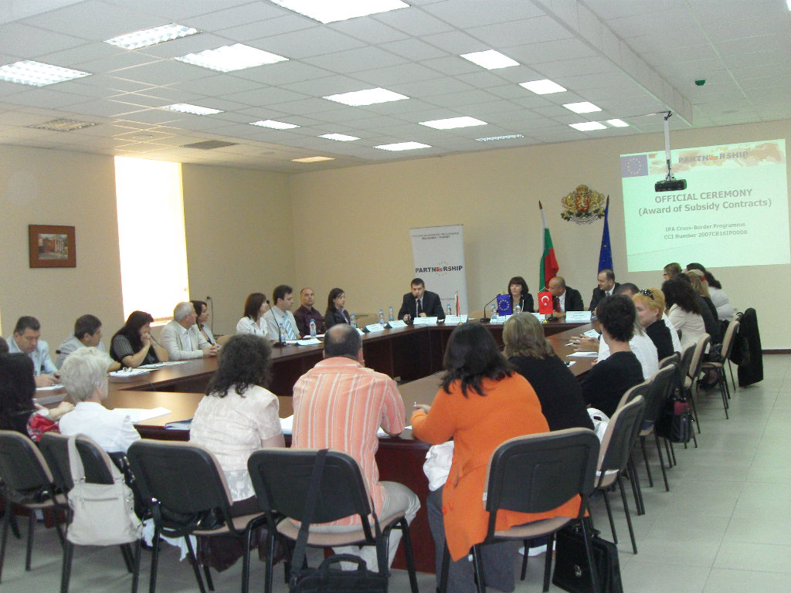

The programme aims to provide opportunities for joint initiatives and practices for social and economic development and for the improvement of the quality of life in the cross - border region (Haskovo, Yambol and Burgas in Bulgaria; Edirne and Kirklareli in Turkey). The project lead partners which receive funding under the 1st Call vary with the % 40 of the governmental institutions (local authority, subsidiary structure of local authority, regional authority, national authority or subsidiary and etc.), % 46 of non-governmental institutions (chamber of commerce, producers associations, and other NGOs.), and in proportion to % 14 other institutions (universities and schools).

As the result of the 1st Call for proposals, the biggest number of the projects according to the area of intervention is within 13 projects in the “infrastructural support for the improvement of the economic potential of the co-operation area”, 12 projects in the “protection of environment, nature and historical and cultural heritage”, and 11 in the “economy competitiveness increasing” area.

As part of the supported Actions numerous and multiple project activities will contribute development of the cross-border region provided however that projects execute a quality implementation. The Joint Technical Secretariat, therefore, in cooperation with General Directorate “Territorial Cooperation Management”, Ministry of Regional Development and Public Works of the Republic of Bulgaria (Managing Authority) and Prime Ministry- Secretariat General for EU Affairs of the Republic of Turkey (National Authority) has organized a training seminar in Haskovo on 4th July 2011 after the Official Ceremony for award of subsidy contracts. This training session was for Bulgarian Lead partners. The second session of the training seminar will be held in Edirne, Republic of Turkey on 13 July 2011 for the Turkish Lead partners.

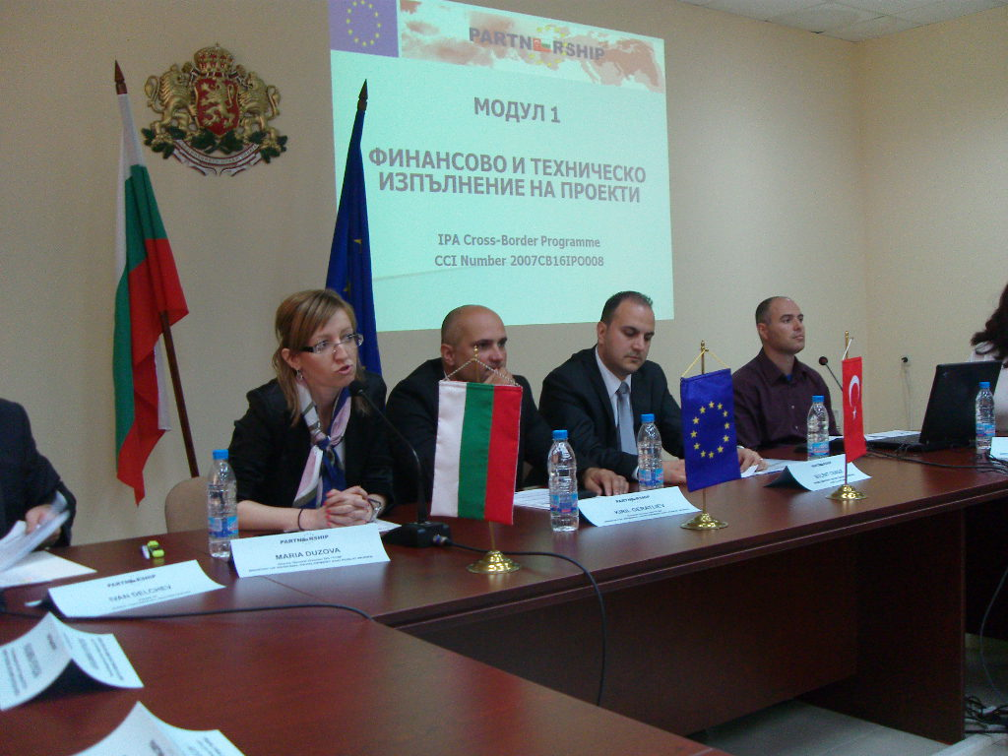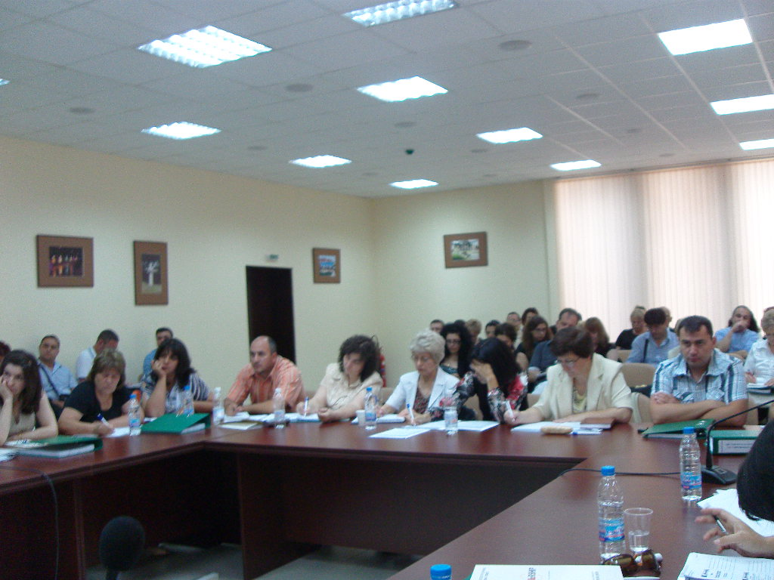

The list of the projects awarded of subsidy contracts will be published on the web-site of the Programme.

