Project number: 2007CB16IPO008-2009-1-022
Project name: Encouraging the eco-friendly business in the cross-border region Topolovgrad - Buyukkaristiran

Partners:
- From Bulgaria: NGO Topolovgrad (Lead Partner)

- From Turkey: Municipality of Buyukkaristiran

Approved budget: 99734, 70 Euro

Project Description:
The project has implemented pilot joint actions for reducing the negative impacts that the businesses have on the environmental factors in the cross border region Topolovgrad – Buyukkaristiran. The main tools towards achieving the goals were: performed preliminary studies and analyses of the negative impacts on the natural resources in the target region; performed researches and applying of good practices in field of eco-friendly business through conduction of visits in preliminary identified 3 companies with already implemented eco-friendly technology; selected 3 pilot companies (one from each target sectors – agriculture, food and textile industries) where external qualified consultancy for conversion has been provided into eco-friendly productions; built capacity of the local stakeholders in field of eco-friendly business and large promotion of the project practices and results.

The project has been successfully accomplished in September 2012.

Pictures from performed events under the project:

Round table in Buykkaristiran
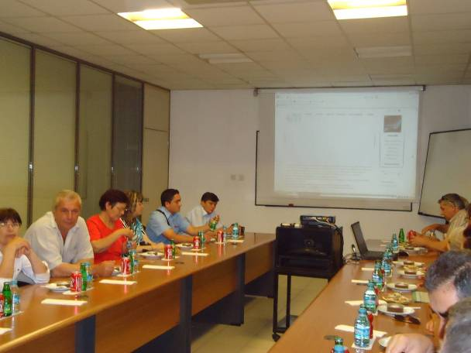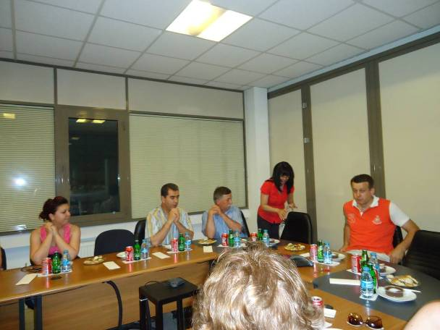

Visits in local companies
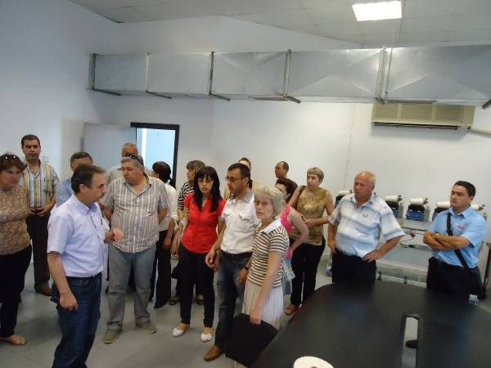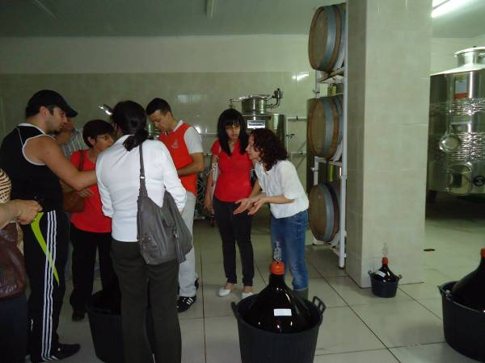

Visits in local wine producers in Buyukkaristiran
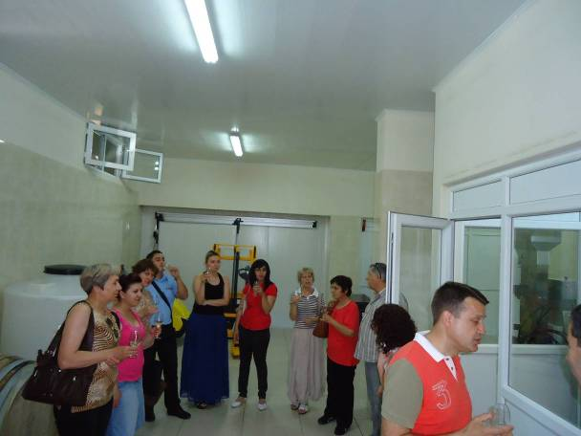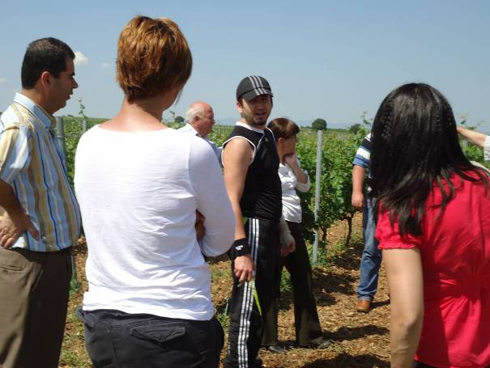

Training in Buyukkaristiran
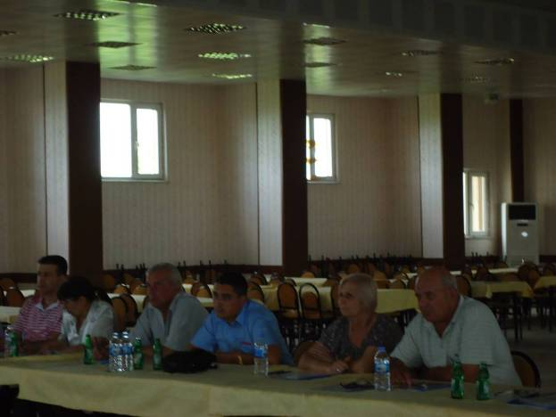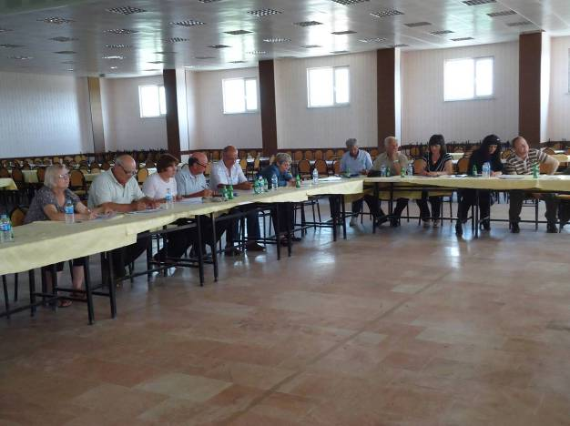

Training in Topolovgad
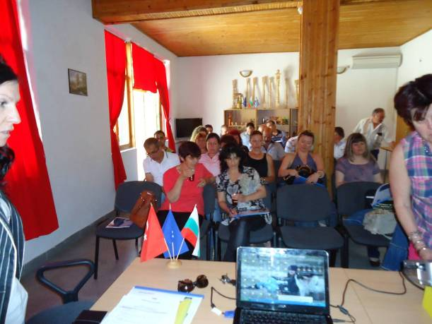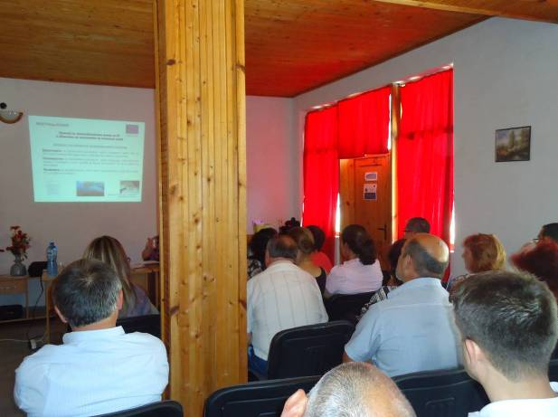

Implementation of eco-friendly technology by the cross-border region
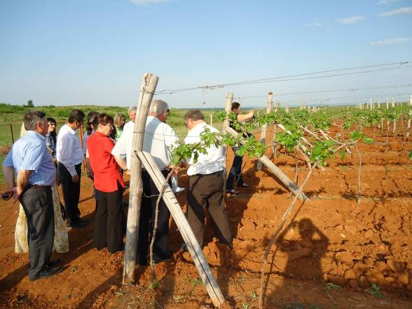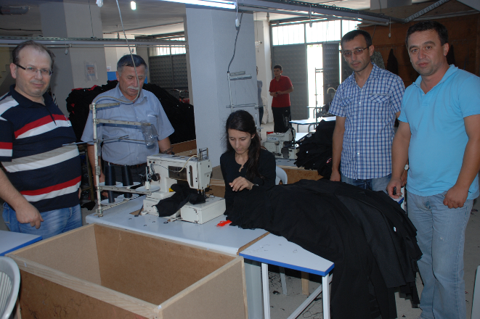

Discussion meeting in Topolovgrad
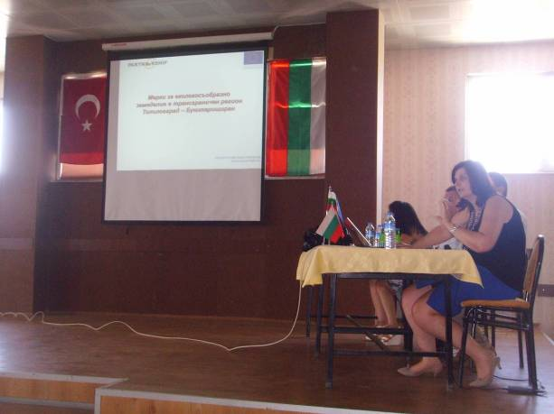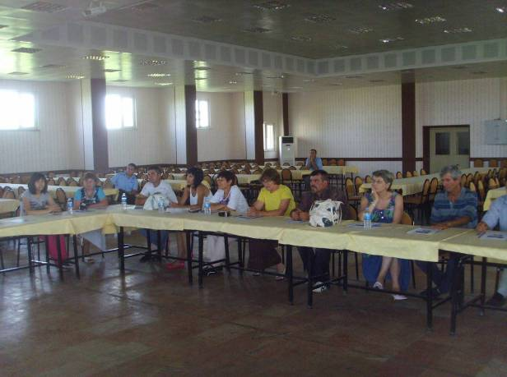

Discussion meeting in Buyukkaristiran
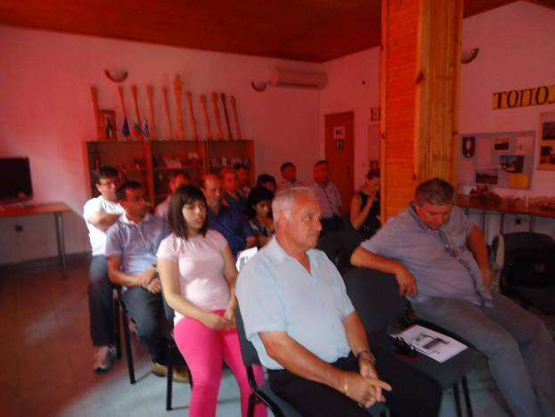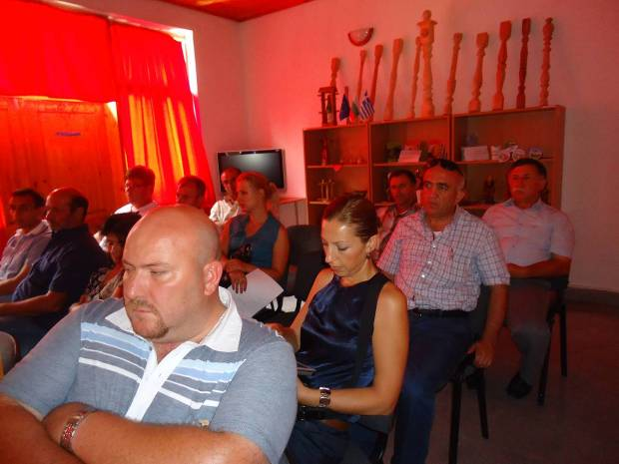

Final Forum in Topolovgrad


