Project number: 2007CB16IPO008-2009-1-097
Project name: Sustainable agriculture development through capacity building and business promotion tools

Partners:
- From Bulgaria: Business Centre Elhovo (Lead Partner)

- From Turkey: Ipsala District Rice Commission

Approved budget: 94380.00 Euro

Project Description:
The project aimed at one hand to increase farmers knowledge in both regions about the other country's agribusinesses, best practices, production, etc and open opportunities to created B2B links and form business partnerships and on the other to raise the capacity of the two partners- beneficiaries as business support providers.
Project objectives were met by performing the following activities: 1) Preparation of a survey report on the state of agriculture in both regions; 2) Development of a joint catalogue of best practices of farmers, 3) Development of a recommendation paper on new (untraditional) crops/animals, relevant for the two regions; 4) Exchange visits of BG and TR farmers to best practice farms; 5) Training of BG and TR farmers; 6) Creation of web-based business support tools for consultancy and information of farmers to be applied by the two partners; 7) Organization of two promotional events - in Yambol and in Ipsala.
As a result of the activities : 1) 150 farmers increased knowledge, skills and know-how as participants in promotional events, exchange visits and trainings; 2) Both project partners accumulated new knowledge on farmers best practices, innovation and recommended untraditional farming for both regions, which can be used in their future support work with farmers; 3) New project proposals developed by project partners for the 2nd call for proposals under the programme; 4) 1 farmer used know- how from TR Rice producers. 1 greenhouse producer will use new practise from BG tobacco producer.1 BG farmer will use seedlings from TR strawberry. 1 farmer will use know-how for growing turf from Turkish; 5) Business support tools will continue to be used by businesses; 6) 150 SME-s participated in promotional events and exchange visits; 7) 33 institutions were reached by the programme. 24 of them were agricultural cooperatives.

The project has been successfully accomplished in July 2012.

Pictures from performed events under the project:

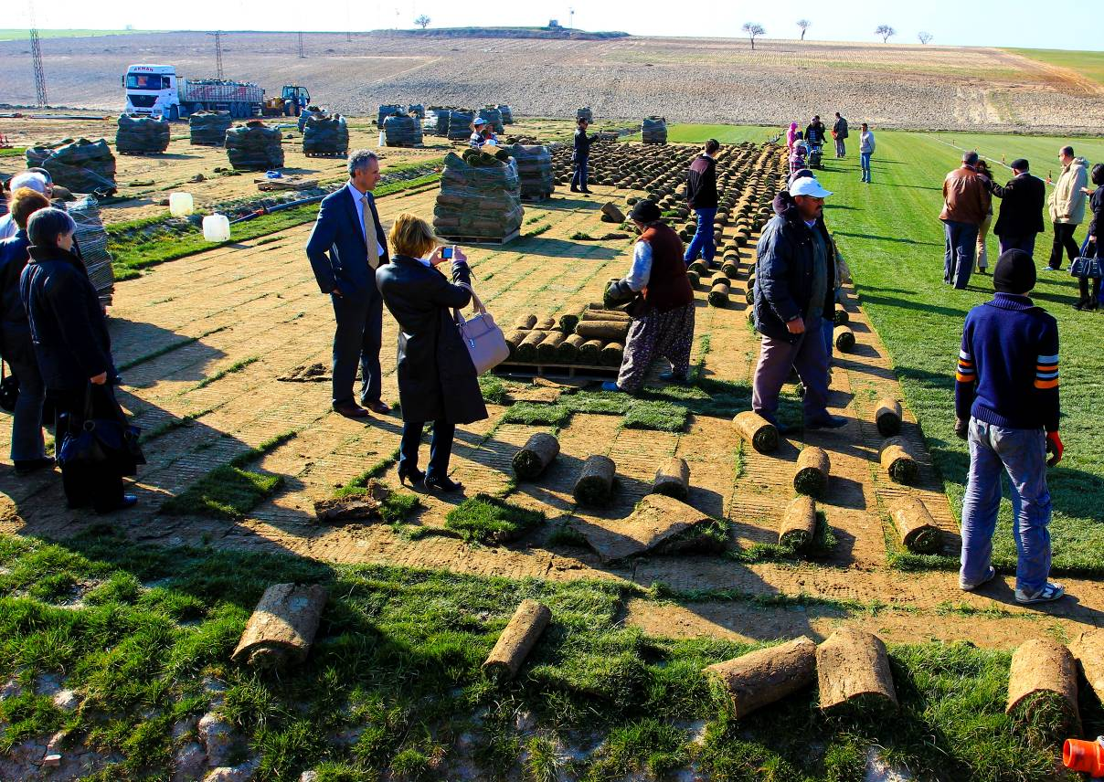

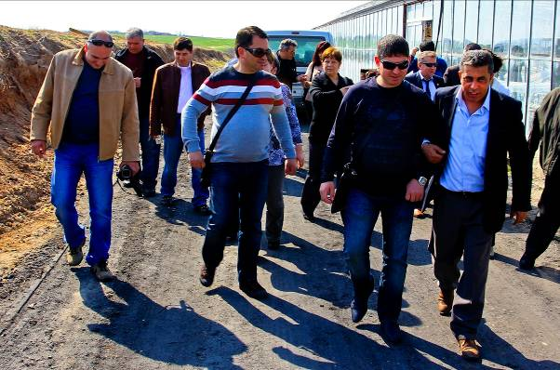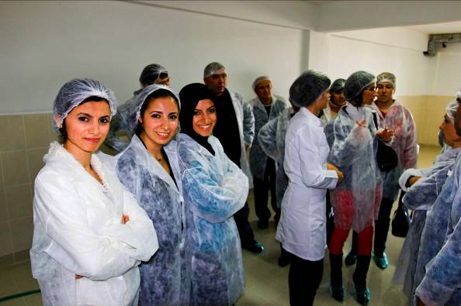

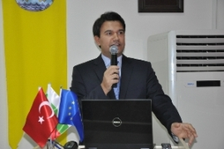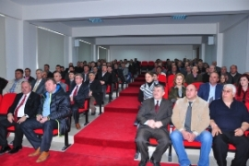
15/03/2012
15/03/2012

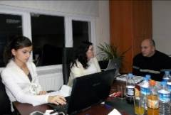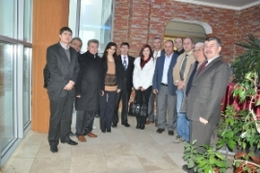
15/03/2012
28/11/2011

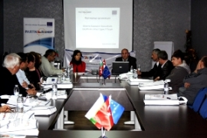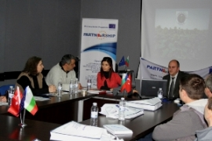
09/03/2012
09/03/2012
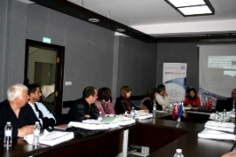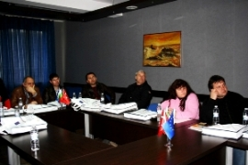
09/03/2012
09/03/2012

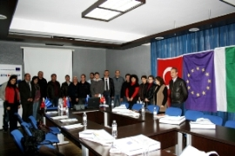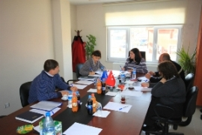
09/03/2012
28/11/2011
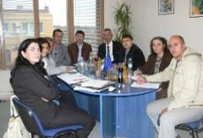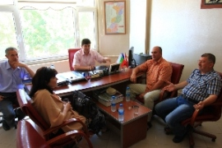
10/10/2011
27/06/2012

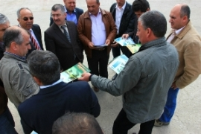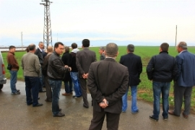
29/03/2012
29/03/2012

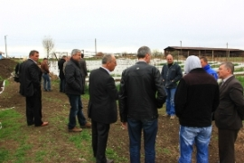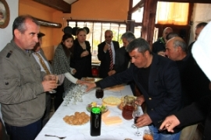
29/03/2012
29/03/2012

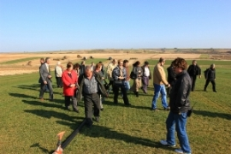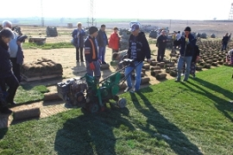
19/03/2012
19/03/2012
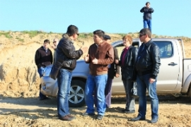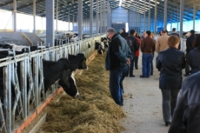
19/03/2012
19/03/2012
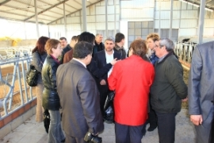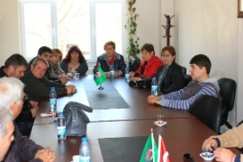
19/03/2012
19/03/2012
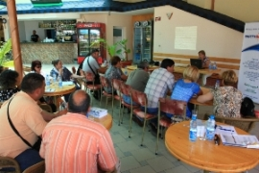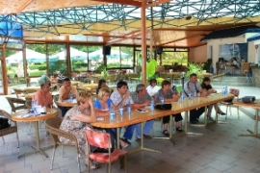
04/06/2012
04/06/2012

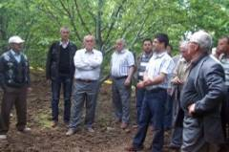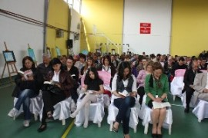
04/05/2012
14/05/2012

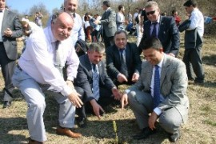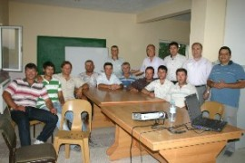
11/06/2012
15/06/2012

