Annex 10

EU flag – reproduction rules

1. Geometric description
The logo has the form of a blue rectangular flag with a wing of one and half times the height of the flag. Twelve golden five-pointed stars (which points do not touch each other) are properly allocated in an invisible circle whose center is at the intersection of the diagonals of the rectangle. The radius of the circle is equal to one third of the height of the flag. Each of the five-pointed stars is situated in an invisible circle whose radius is equal to one eighteenth of the height of the flag. All stars are upright, i.e. one of the rays pointing upwards and two beams resting on an invisible line at right angles to the flagstaff. Stars are available as a clock dial numbers. Their number is invariable.
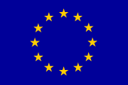

2. Original colors
The emblem is in the following colours:
PANTONE REFLEX BLUE for the surface of the rectangle; PANTONE YELLOW for the stars. The international PANTONE range is very widely available and easily accessible even for non-professionals.
Four-color process
If the four-color process is used, it is not possible to use the two standard colours. It is therefore necessary to recreate them by using the four colours of the four-color process. The PANTONE YELLOW is obtained by using 100% "Process Yellow". By mixing 100% "Process Cyan" and 80% "Process Magenta" one can get a colour very similar to the PANTONE REFLEX BLUE.

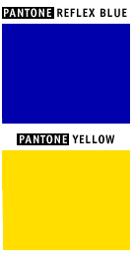
Internet
PANTONE REFLEX BLUE corresponds in the web-palette colour RGB:0/51/153 (hexadecimal: 003399) and PANTONE YELLOW corresponds in the web-palette colour RGB:255/204/0 (hexadecimal: FFCC00).
3. Reproduction in monochrome technology
3.1. Black and White:
If only black is available, outline the rectangle in black and print the stars in black and white.
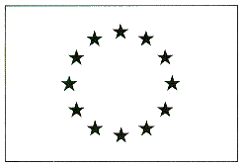
3.2. Blue and White:
In the event that blue is the only colour available (it must be Reflex Blue, of course), use it 100% with the stars reproduced in negative white and the field 100% blue.

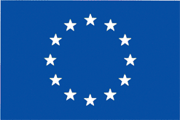

4. Reproduction on coloured background

The emblem is reproduced for preference on a white background. Avoid a background of varied colours, and in any case one which does not go with blue. If there should be no alternative to a coloured background, put a white border around the rectangle, with the width of this being equal to 1/25 of the height of the rectangle.
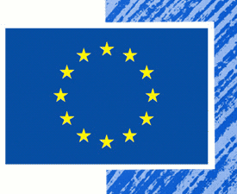

5. Electronic version
More detailed requirement on the flag creation and utilization (including: geometry, colours, background etc.), as well as the electronic version of the EU flag can be seen and downloaded from the following EU web page: http://europa.eu/abc/symbols/emblem/download_en.htm

6. Examples of incorrect reproduction
- The emblem is upside down. | 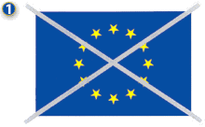
- The stars are not upright. | 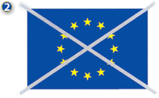
- The stars are wrongly positioned in the circle: they must appear in the position of the hours on the face of a clock. | 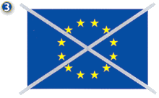

THE PROGRAMME LOGO OF THE Bulgaria-Turkey IPA CROSS-BORDER PROGRAMME

1. Logo

The logo of the Programme plays a role of utmost significance in creating brand association regarding visual communication.

The logo of the Programme should not be recreated in any circumstance. Only the logo version presented in this manual is the correct one and it and only it should be used.

The logo of the Programme should be used on all materials issued by the authorities / beneficiaries only in English.

For beneficiary’s convenience, here is the original version of the Programme logo of the Bulgaria –Turkey IPA Cross-Border Programme:



2. Logo Versions & Backgrounds

The chromatic versions of the logo are:

- Full color version. This version is highly recommended when there are no restriction imposed by the texture and color of the material (white background) on which the visual identity of the programme is applied.



- Grayscale versions with the two subversions: compact and outlined logos. These versions are recommended when applied through serigraphy and engraving procedures or/and on restrictive surfaces of certain materials - fax, stickers – whenever the full-color version of the logo cannot be applied.

NB! | The grayscale versions of the logo (either compact or outlined) will be used only on a colored background or on a photo.

3. Spacing

The logo should not be oversized.

In order to create the maximum impact and visibility, the presence of a white space around the graphic signature is very efficient.

This space individualizes the logo by separating it from the surrounding elements (margin of the page, other logos or graphic elements, etc.).

4. Font

Arial
AaBbCcDdEeFfGgHh
Arial Italic
AaBbCcDdEeFfGgHh
Arial Bold
AaBbCcDdEeFfGgHh
Arial Bold Italic
AaBbCcDdEeFfGgHh

For communication and publicity purposes, the logo should be downloaded only from here or from the official site of the Bulgaria – Turkey IPA Cross-Border Programme CCI number 2007CB16IPO008.
5. Examples of incorrect reproduction
- The emblem is distorted.
- Use of different than the original colours | 

Visual identification: Practical recommendations

1. Project logo
In addition to the EU logo and the logo of the Bulgaria – Turkey Bulgaria – Turkey IPA Cross-Border Programme CCI the beneficiaries could use, also their normal logo (or letterhead).
If they decide to create a special logo/sign/phrase for their correspondence and communication activities, related to this particular project, it is recommended to rely on an experienced designer/PR expert in order to ensure a good quality of the logo/sign/phrase.

2. Media related information actions
The communication experts are advised to be proactive and to inform the media on a regular basis on the social goals and impact of their project, as well as on its progress. In this relation, special Press releases, summarizing the most important information on the project /or a special event/ should be distributed to the respective representative of the media. When possible some selected photos could also be included. The press release should incorporate the EU flag, the logo of the Bulgaria–Turkey IPA Cross-Border Programme and the name of the project.
If a press conference is organized, the EU flag and a special banner about the project should be displayed.
The communication experts of the project could also organize visits for journalists to the project site (or invite them at a special project event) to make the project and the Programme more visible for the general public. The timing ant the focus of such visits shall be well chosen.

3. Display panels
The information boards/ billboards/ plaques /posters/ signs should display the following information (that should cover at least 25% of the total area of the board):
1) the logo of the European Union;
2) the Programme logo of the Bulgaria – Turkey Bulgaria – Turkey IPA Cross-Border Programme .
3) the name of the project;
4) the sentence: "The project is co-funded by EU through the Bulgaria – Turkey IPA Cross-Border Programme (CCI number 2007CB16IPO008)”.
During the implementation of the project the beneficiary should display info-board /billboard at the place where the activities on the project take place in case the project involves infrastructure or construction activities.

4. Commemorative plaque
After the completion of the project a permanent commemorative plaques could be used to acknowledge the contribution of the Bulgaria – Turkey IPA Cross-Border Programme in the planning or construction/reconstruction of a building (for ex.: social organization office, training centre, school, library etc.), road, bridge, other small scale infrastructure site or cultural site. The commemorative plaque should be placed on the most appropriate visible part of the site and should contain the sentence:
“This <site/project/operation> was supported by the Bulgaria – Turkey IPA Cross-Border Programme CCI number 2007CB16IPO008”.
Below is an example plaque:
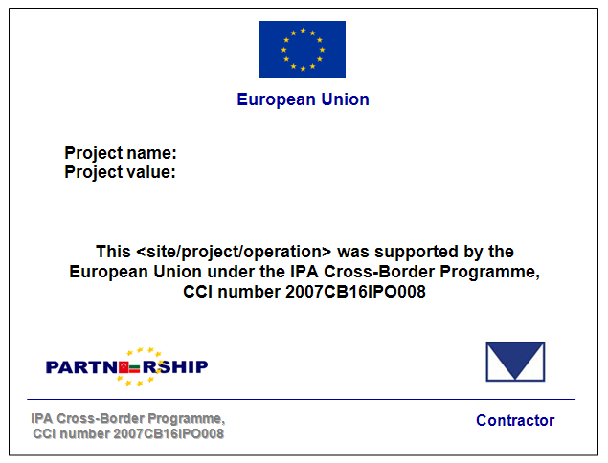

If the operation continues to develop and the next phases are not co-financed by the Bulgaria – Turkey IPA Cross-Border Programme, the commemorative plaque’s text could be the following:
“The planning (the initial phase) of <site/project/operation> was supported by the Bulgaria – Turkey IPA Cross-Border Programme (CCI number 2007CB16IPO008).”

5. Signs and stickers
Signs or stickers should be placed on purchased equipment or materials and to be clearly visible that it has been obtained under the Bulgaria – Turkey IPA Cross-Border Programme (CCI number 2007CB16IPO008).
The sign / sticker should indicate the name of the project and the two logos:
1) the logo of the European Union;
2) the logo of the Bulgaria – Turkey IPA Cross-Border Programme.
The sign / sticker should be made of durable material in order to provide the above mentioned information for a longer period.

6. Information and publicity materials
The cover page of all printed information materials (brochures, flyers, newsletters, information bulletins and certificates of trainings, etc.) should include the following:
1) the EU logo
2) the logo of Bulgaria – Turkey IPA Cross-Border Programme;
3) the name of the project;
4) the sentence "The project is co-funded by EU through the Bulgaria – Turkey IPA Cross-Border Programme (CCI number 2007CB16IPO008)”.
If possible the above information should be included in the header and/or footer bars of each page of the publication.
The above elements should also appear on the promotional item (T-shirts, caps, folders, umbrellas, flags, PC paths, key-holders, pens etc.). If the promotional item is too small (for ex.: pens) to include all four information elements, at least the EU flag should appear and - if possible – the following text: Bulgaria – Turkey IPA Cross-Border Programme (CCI number 2007CB16IPO008).
In case of a cap or t-shirt the European logo should appear on the front of the item. If possible from design point of view the program logo should also appear on the front under the EU logo.

Example:
FRONT BACK
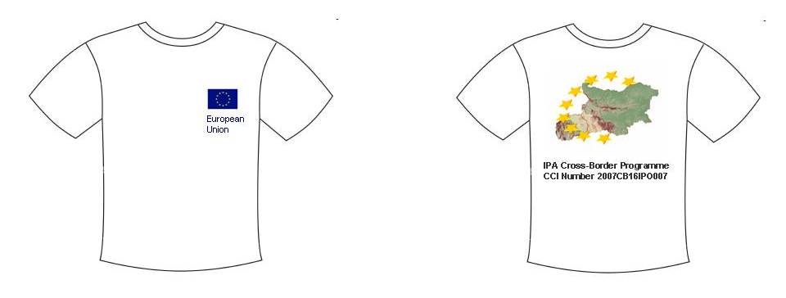

7. Events
During the course of a project implementation or to celebrate its successful completion various public events could be organized: info-events, training courses, conferences, workshops, seminars, fairs. When such an event takes place, it is mandatory to display a special banner of the project – with the EU logo, the logo of the Bulgaria – Turkey IPA Cross-Border Programme and the name of the project. The invitation, the programme, and all written materials from the event (incl. training materials) should also contain the name the above element.
If representatives of the media are invited a special press release should be prepared by the communication expert and distributed to them before the event. At the end of the event interesting photos and summary should also be submitted to the journalists.
8. Banners
Plastic or textile banners should be placed in the halls where seminars, conferences, workshops, info-days, exhibitions/fairs are taking place. The following information should cover at least 25% of the banner’s surface:
1) the EU logo;
2) the Programme logo of the Bulgaria – Turkey IPA Cross-Border Programme.;
3) the name of the project;
4) the sentence "The project is co-funded by EU through the Bulgaria – Turkey IPA Cross-Border Programme (CCI number 2007CB16IPO008)”.

9. Articles, interviews and other publications
It is mandatory to quote the name of the project and the fact that it is co-financed under the logo of Bulgaria – Turkey IPA Cross-Border Programme.
In addition it is also recommended:
- for the interview: to organize it in front of/or around a visual sign of the EU and Programme logo;
- for the article/publication: if possible to include the EU and the Programme logos.
When a publication, displaying the EU logo, contains study or research results or personal remarks/reflections the following statement should be included:
"This publication has been produced with the assistance of the European Union. The contents of this publication are the sole responsibility of <Name of the author/ beneficiary> and can in no way be taken to reflect the views of the European Union.”
If not only the EU logo, but also the logo of the logo of Bulgaria – Turkey IPA Cross-Border Programme is displayed the clarifying text should be amended as follows:
"This publication has been produced with the assistance of the European Union through the Bulgaria – Turkey IPA Cross-Border Programme. The contents of this publication are the sole responsibility of <Name of the author / beneficiary> and can in no way be taken to reflect the views of the European Union or the Managing Authority of the Programme.”
10. Web sites/ e-bulletins/ e-magazines
The content of the web site / e-bulletin/ e-magazine must be concise, factual and easy to understand. The EU logo and the logo of the Bulgaria – Turkey IPA Cross-Border Programme must appear on every page.
In addition:
- the site should be targeted to the respective project’s audience;
- the important information should appear on the top of the first page;
- the posted information should be accurate and relevant (but not superfluous); and overloaded with information);
- the language used should be simple and objective;
- the layout of the site should be easy to read and consistent (every page should have the same font, font style and size, graphs and charts , etc.).
- the site should be regularly updated with enough visual information.

